I’m analyzing this for my daily hand reading exercise, so I will appreciate any and all feedback. I’m going to start with an assumption of a table/player that likes to see a lot of flops and doesn’t 3 bet so I can give them an uncapped range. I put them around 41% of hands for their range and our equity is Our Equity vs this range is 49.267% with KdTs .They may even be wider than this from the big blind getting good odds with limpers already. (so 2 caveats already, they probably do have a 3-bet range; slightly more likely to play a larger range from BB).

Figure 1: Pre-flop villain BB range
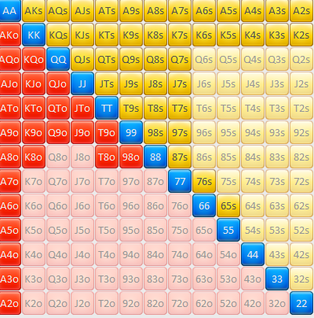
(AA-22,AKs-A2s,KQs-K2s,QJs-Q7s,JTs-J7s,T9s-T7s,98s-97s,87s,76s,65s,AKo-A2o,KQo-K8o,QJo-Q9o,JTo-J9o,T9o-T8o,98o)

Flop
AdTd3h
(Hero equity against this range is 59.804$)

Villain leads from BB facing two people behind with approx. 1/3 pot bet, and the hero pre-flop raiser in position on everyone. My thoughts are conflicting A) they are scared to face a bet and so want to take control (have a good Draw QdJd; don’t want to have to lay down an Ax hand); B) they do have value and so they want to bet. I don’t know the player pool to know what the lead means here. The range I came up with is below, we have 40.714%equity, and this range is 62.2% of the previous range for 247 combos.

Figure 1: Villain Flop Action Range:

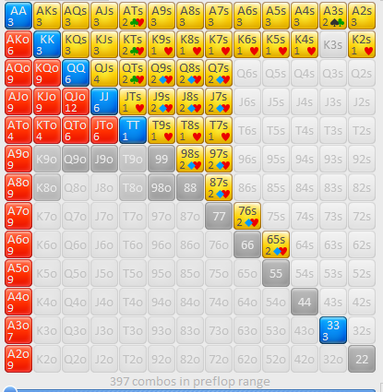
AA-22,AKs-A2s,KQs-K2s,QJs-Q7s,JTs-J7s,T9s-T7s,98s-97s,87s,76s,65s,AKo-A2o,KQo-K8o,QJo-Q9o,JTo-J9o,T9o-T8o,98o

River:
AdTd3h Ac

We are now down to 39.213% equity. The river cut out around 46 combos of Trips but there are still 78 combos of 3 of a kind. Here is where someone could really help to see if I’m doing anything that is useful. I looked at their no made hands to see how many were just complete air. They had 69 No made hands, 41 of those were still drawing a flush or a gutshot; and if they cut out those complete misses they have 183 combos of which 41 are draws, 24 are middle pair (which you chop or cut), and 15 are a pocket pair that beat you. (probably a better way to prevent this, but here is the matrix:

Figure 3: River range dropping complete air
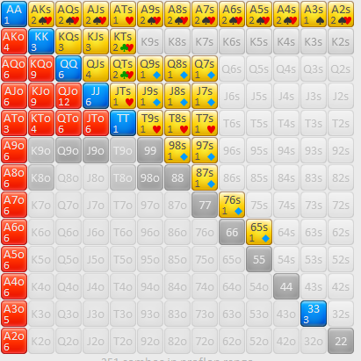
AA-22,AKs-A2s,KQs-K2s,QJs-Q7s,JTs-J7s,T9s-T7s,98s-97s,87s,76s,65s,AKo-A2o,KQo-K8o,QJo-Q9o,JTo-J9o,T9o-T8o,98o

The pot odds are there with such a small bet (we have 33.544 equity against this range).The 7s improves our equity to 39.779%. I think we are getting the correct odds here to call, but the betting pattern makes me think they are on the top end of their range and we are beat.

I think to better understand this I may need to look at what your opponent thinks of your range

I’ve been spending half an hour trying to dissect the story they told with their betting and why I think they are at the top of their range, and am kind of stuck, so would appreciate feedback on why I might think that (probably taking the villain PoV and trying to figure out what they think Hero’s range is would help? Maybe?). Also appreciate constructive criticism on the analysis, and how to better present this information.

(writing has never been a strong suit).

Best,
DJ

